**Backup a Database Using an EC2 Instance and Store It in S3**

**Step1: Create an EC2 Instance**

In the AWS Management Console, go to **EC2** and click **Launch Instance**:

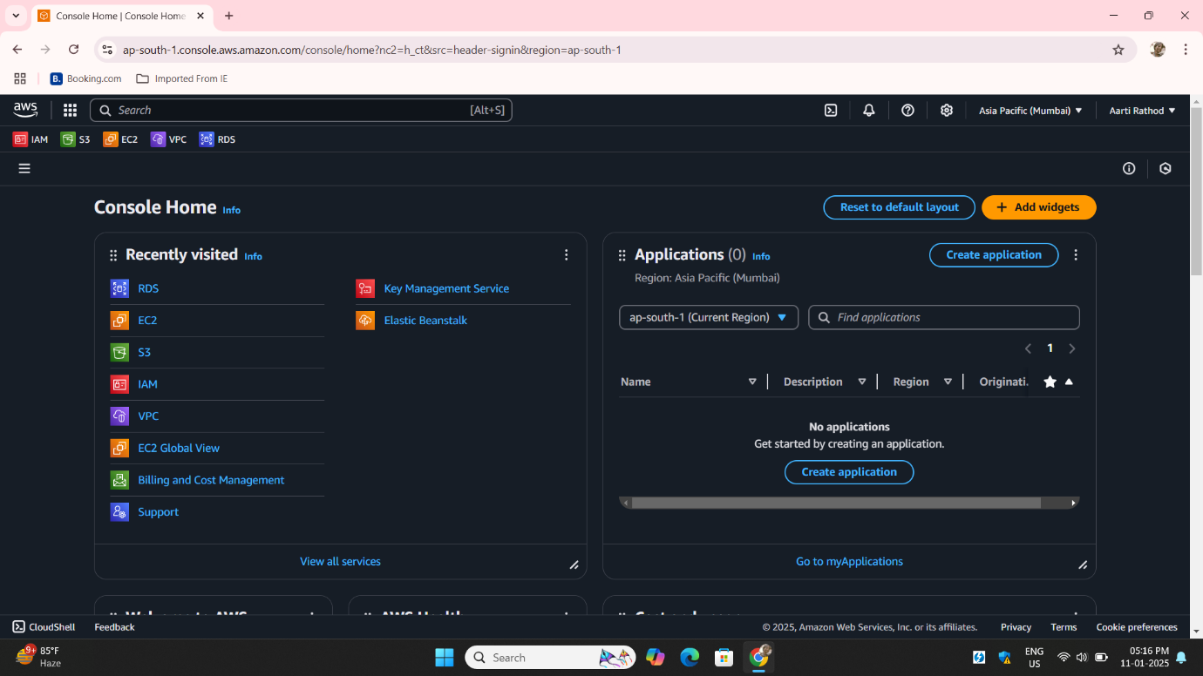

**Step2**: Give a Name to Instance Choose an **Amazon Linux 2 AMI** or your preferred Linux AMI.

Select an **instance type** 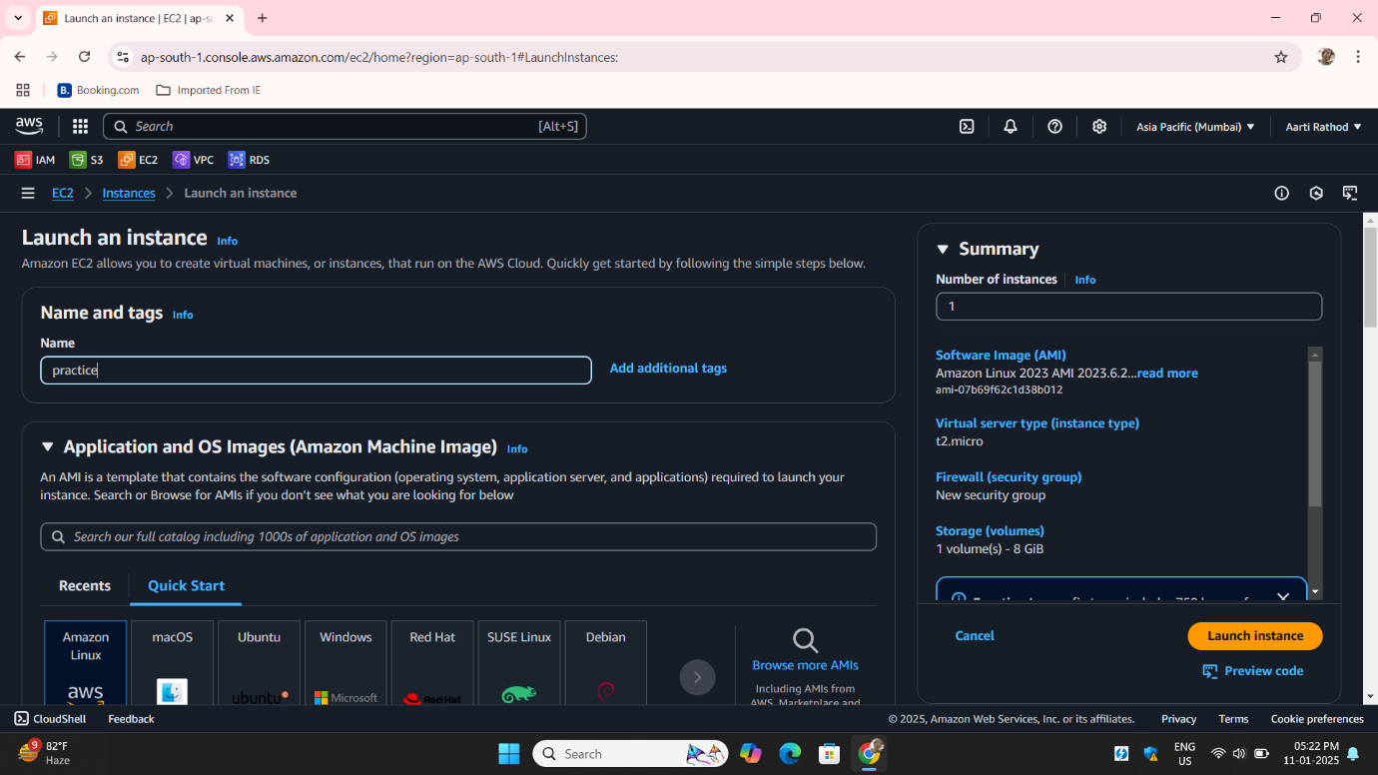

**Step3**: Select an **instance type** Create a new **Key Pair** or select an existing one to access the instance via S

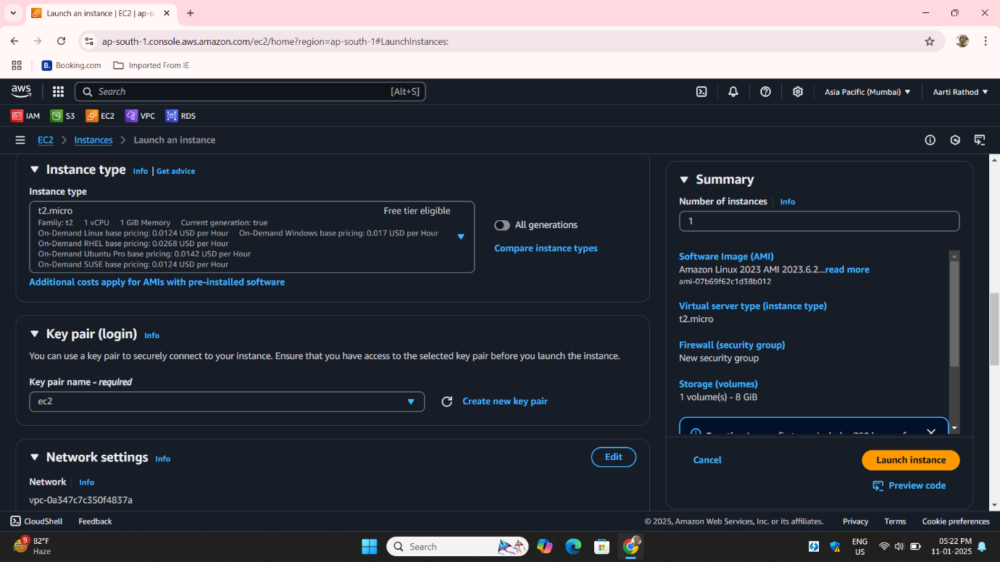

**Step4**: Set security group rules to allow SSH (port 22) access. Click **Launch** Instance

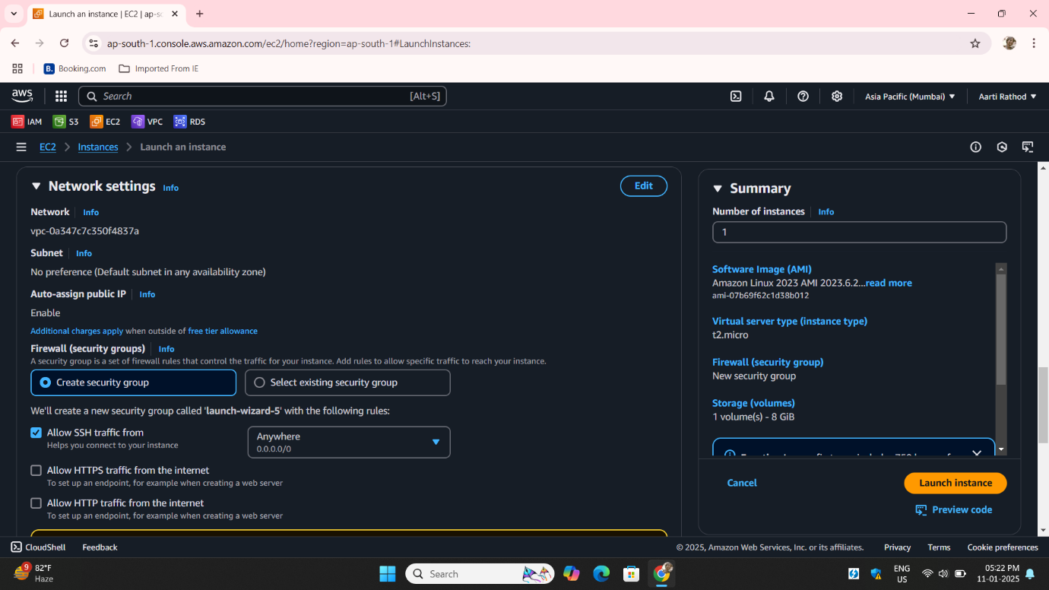

**Step5**: Create an IAM Role and Attach to EC2 Instance

Go to **IAM** in the AWS Management Console.

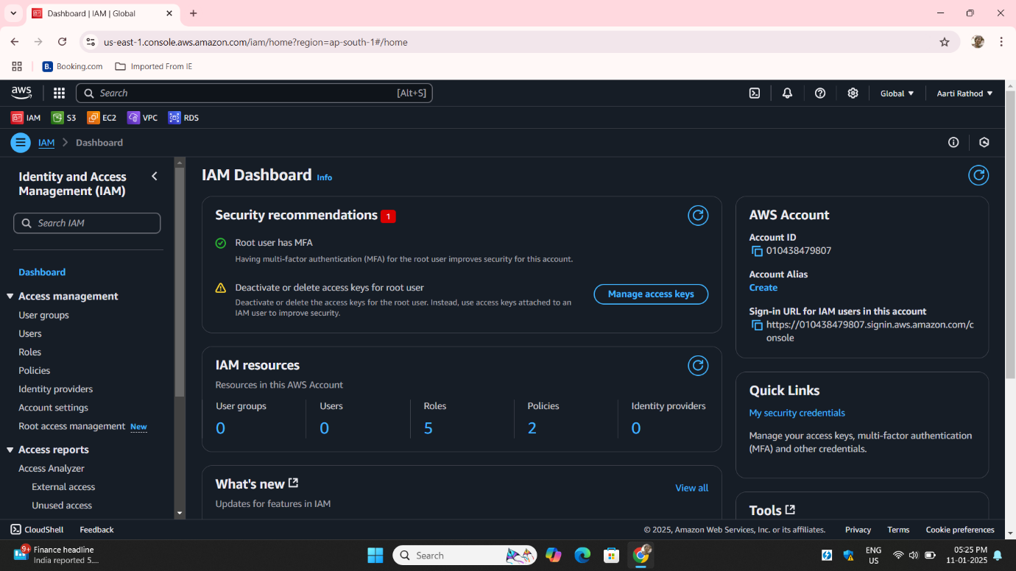

**Step6**: Click **Roles** and then **Create Role**:

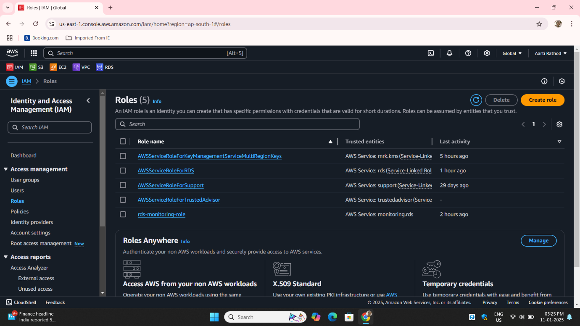

**Step7:**: Choose **Trusted entity type** :**aws service:-**

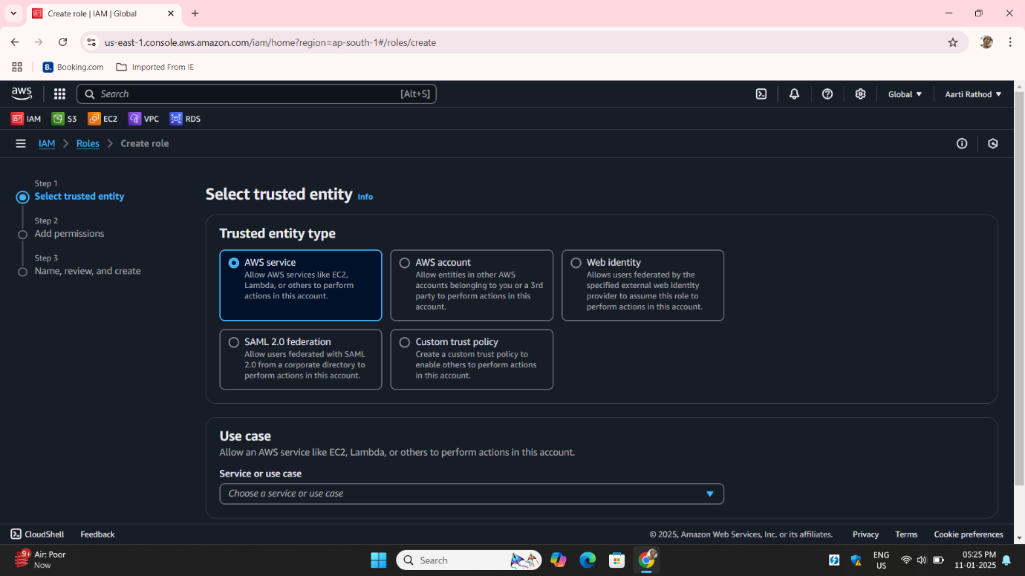

**Step8:**  Attach the following policies**:AmazonS3FullAccess (for accessing S3).**

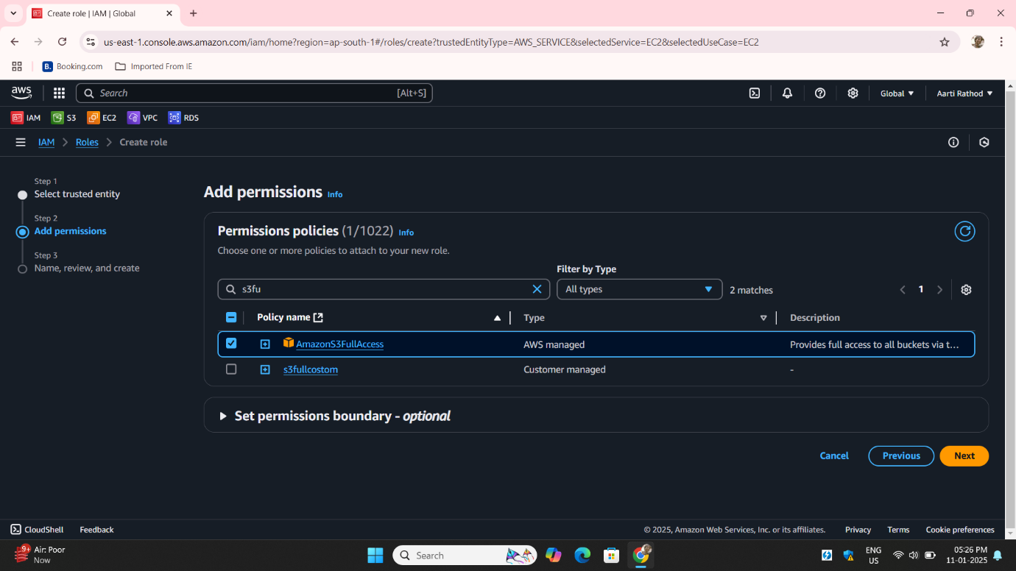

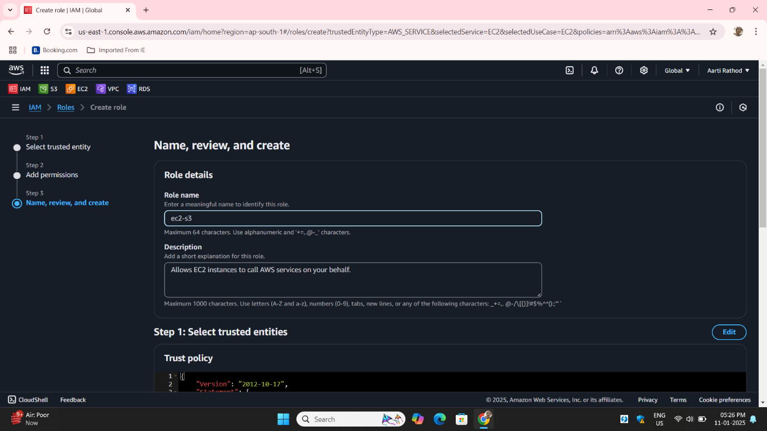**Step9:** : Give the role a name then click **Create Role**.

**Step10: Attach the IAM Role to EC2 Instance:** Go to the **EC2 Dashboard**, select the instance you just created.

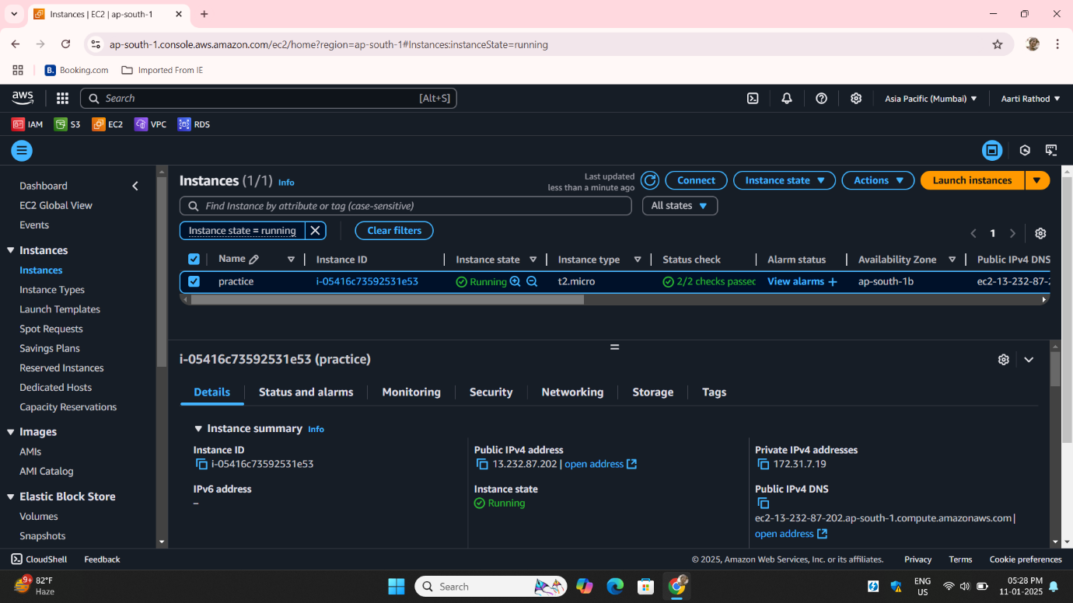

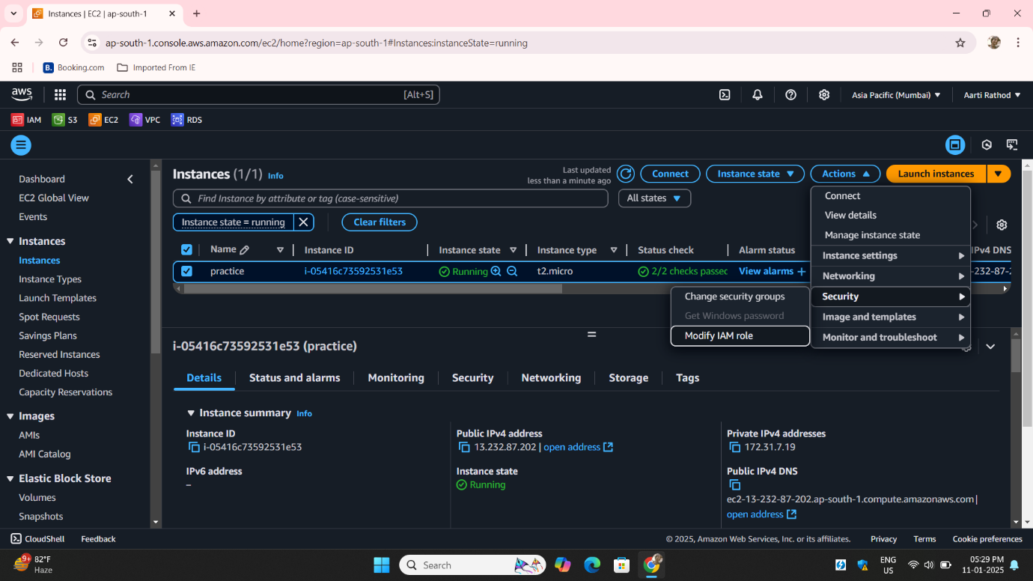**Step11**: Under **Actions**, choose **Security** > **Modify IAM Role**.

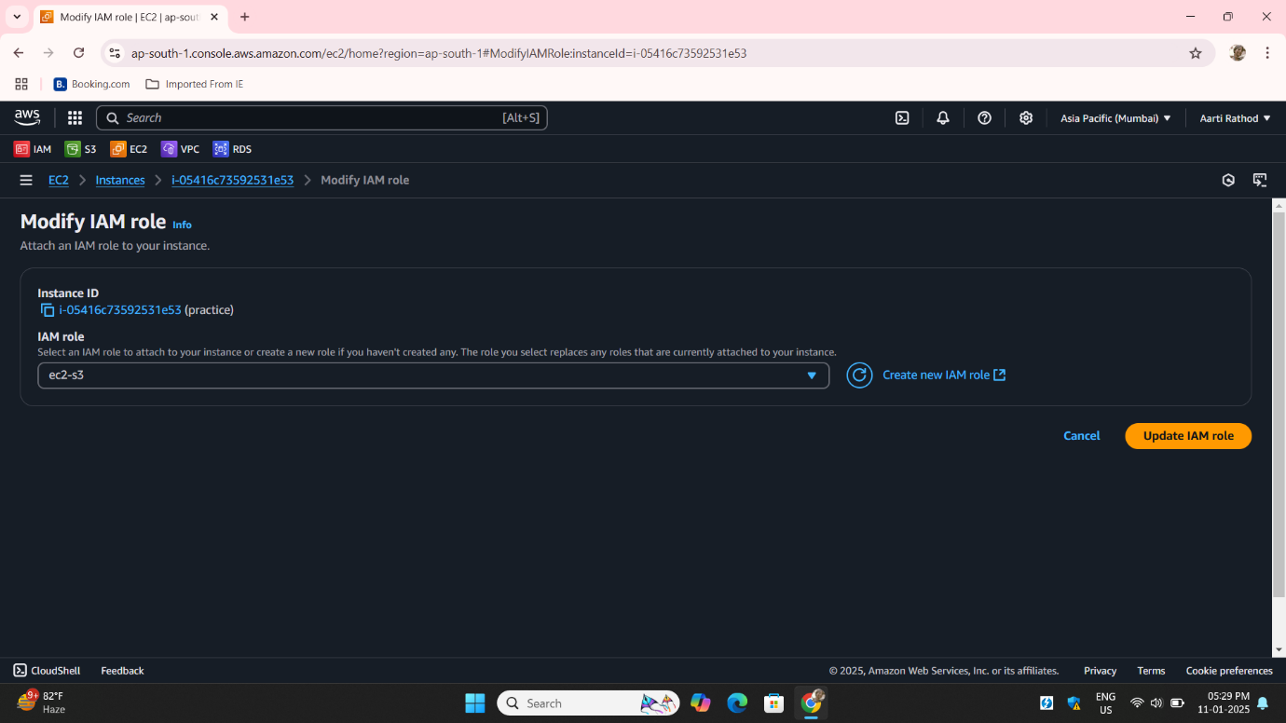**Step12**: Select the IAM role you just created and click **Update IAM role**.

### **Step13**: **Open the S3 Console** Navigate to the **Amazon S3** service S3:

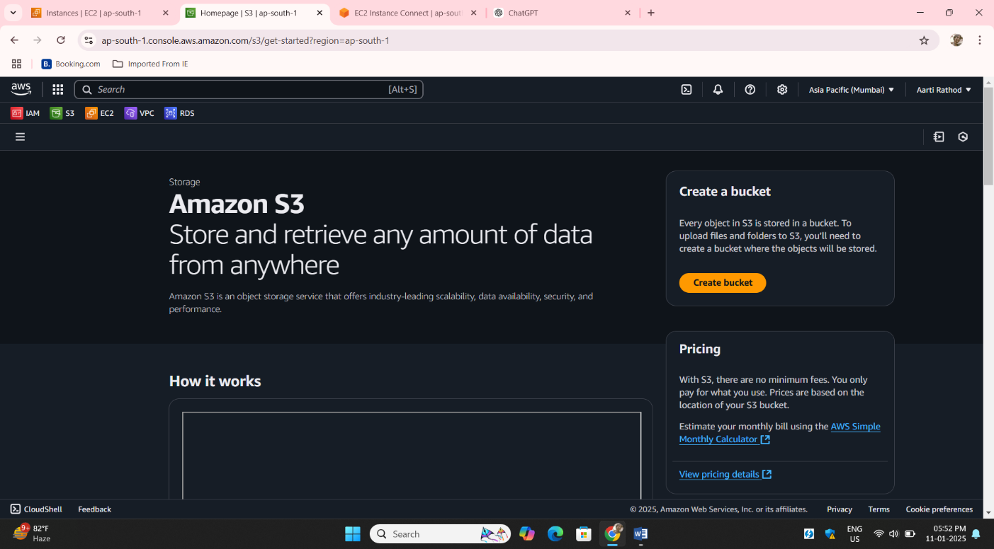

### **Step14: Click Create Bucket** In the S3 console, click on the **Create Bucket** button.

Enter a unique name for your bucket Bucket names must be globally unique and follow naming rules:

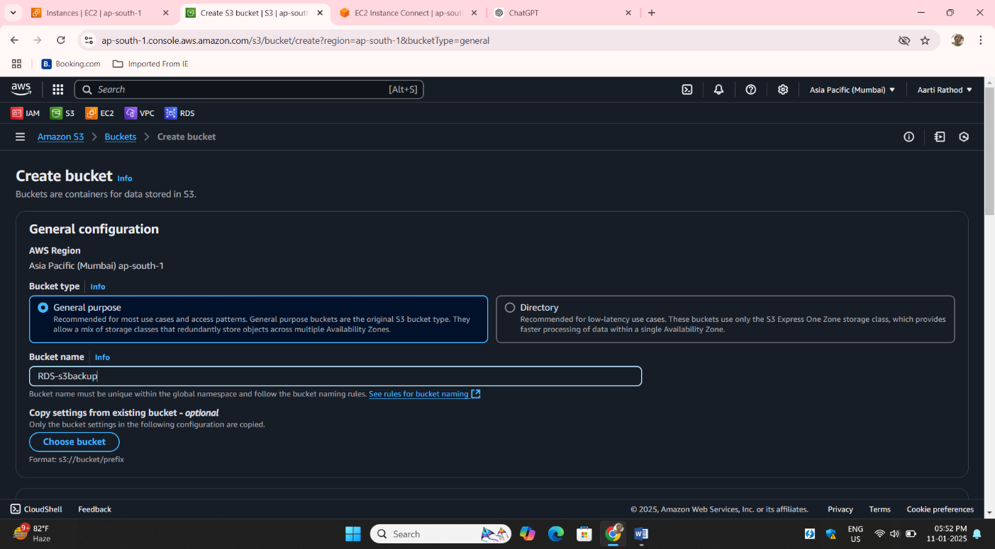

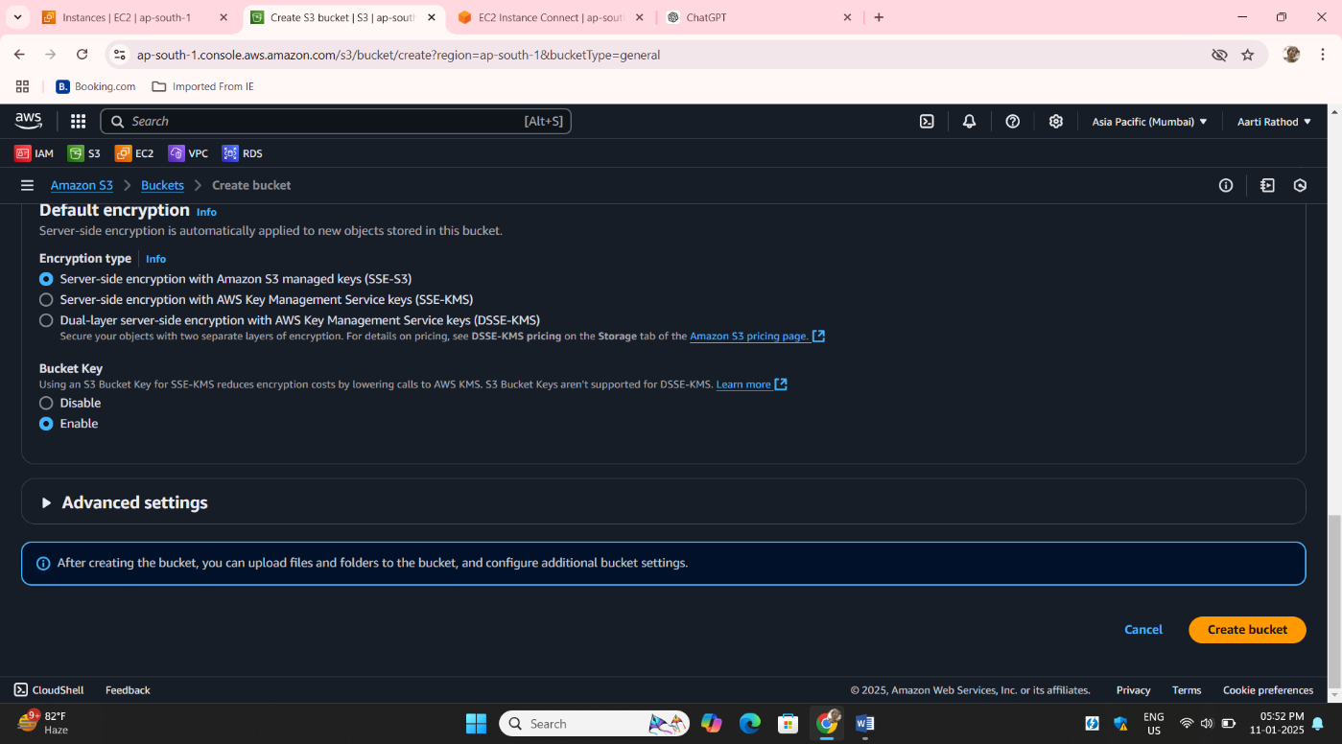**Step15**: Keep all other steps by default Click **Create Bucket** to finalize.

**Step16**: Connect to EC2 Instance On CLI:

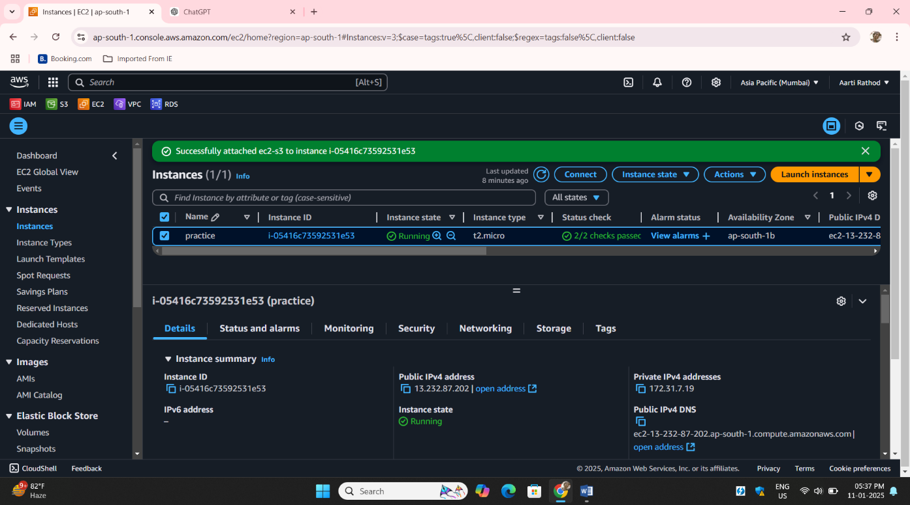

**Step17**: Install **MariaDB** on EC2:

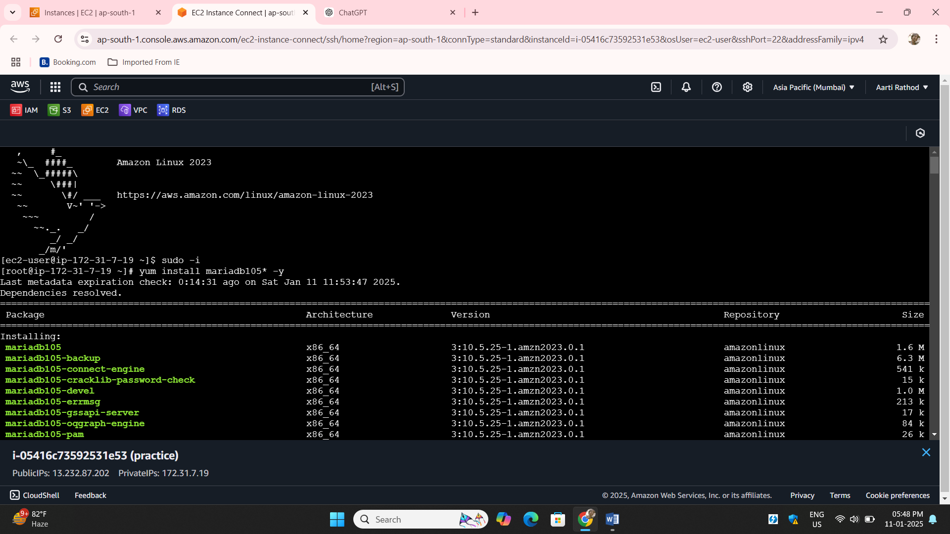

#### ****Step19: : Secure MariaDB Installation** Run the Secure Installation Script:**

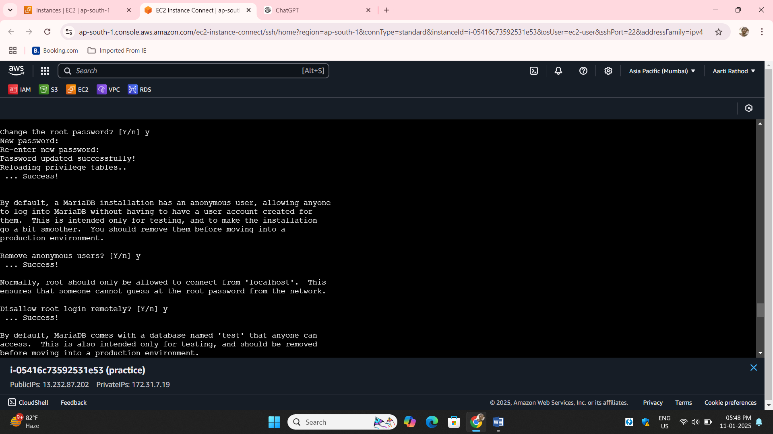**Step20**: Set the new password for root:

#### ****Step21: Connect to MariaDB and Show Databases** Login to MariaDB:** Enter the password you set during the secure installation.

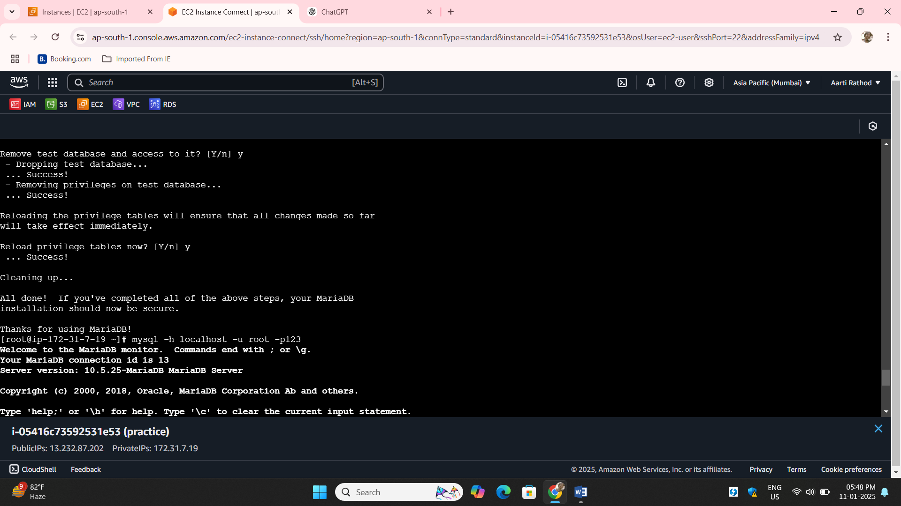

**Step22**: Show Databases Create a New Database called Rohan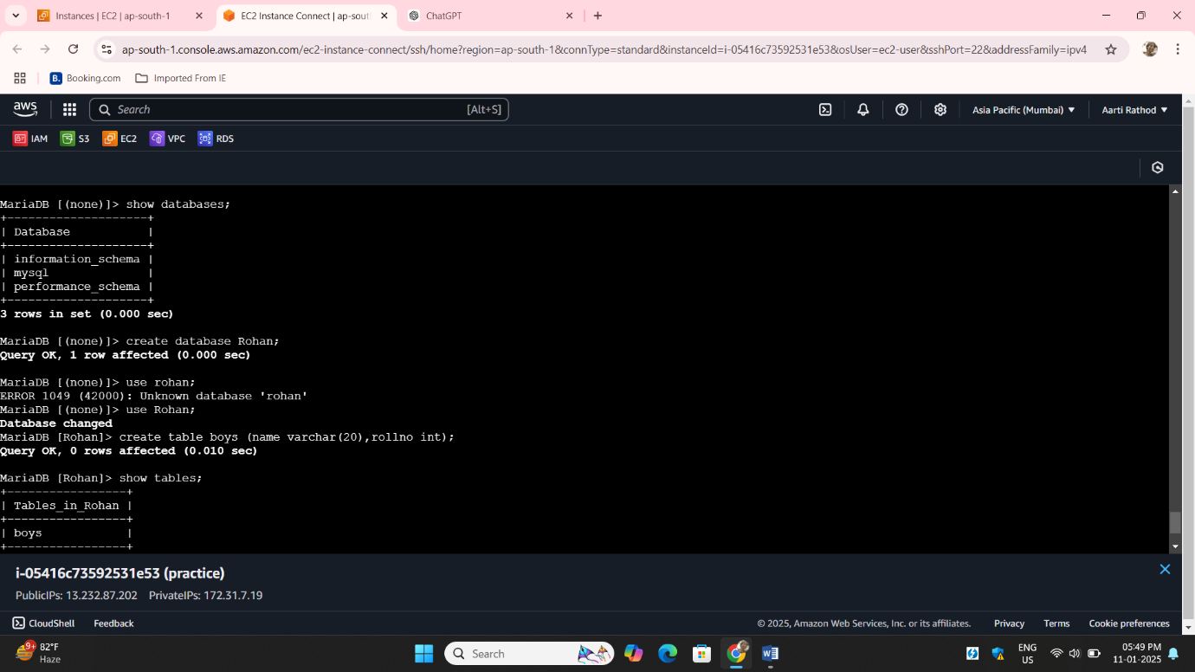

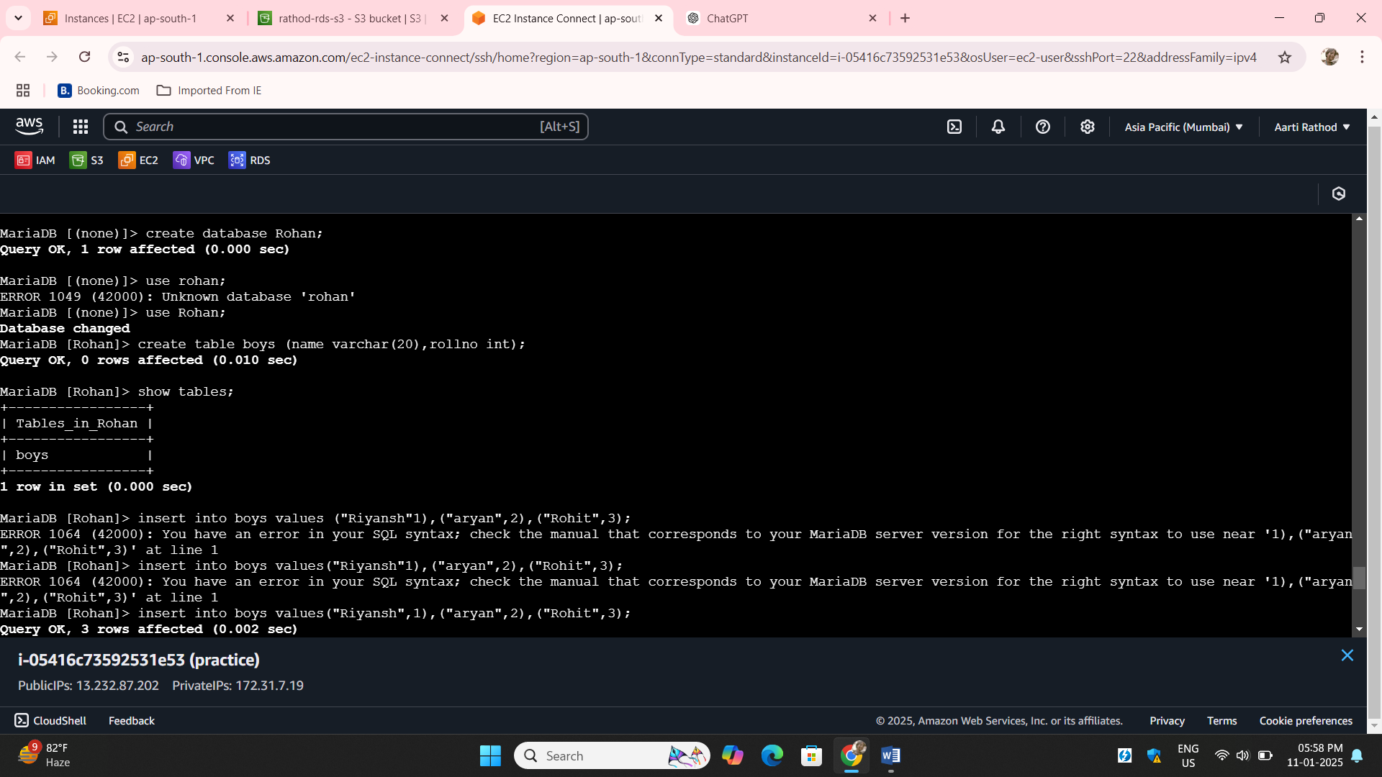**Step23**: Create table boys insert daya into it

**Step24**: Creates a backup of the Rohan database and saves it as a file named backup.sql

Ls check if backup.sql is created.

**mysqldump -u root -p123 Rohan > rathod-rds-s3**  
Creates a backup of the Rohan database and saves it as a file named rathod-rds-s3.

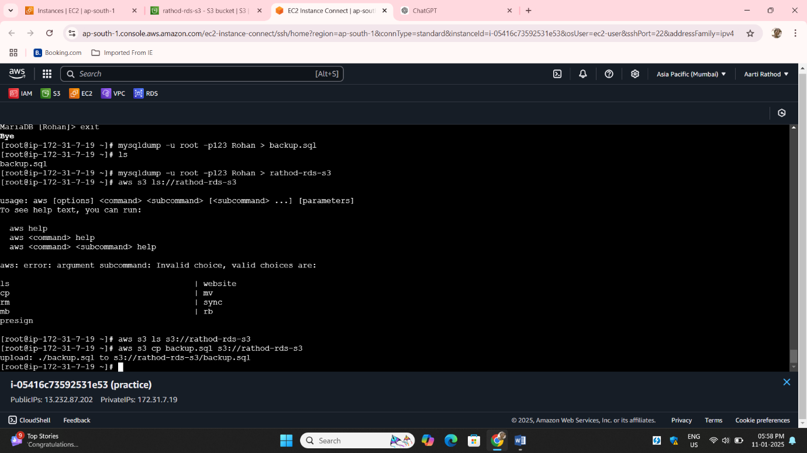**aws s3 ls s3://rathod-rds-s3**  
Lists the contents of the S3 bucket named rathod-rds-s3 to check if the backup file

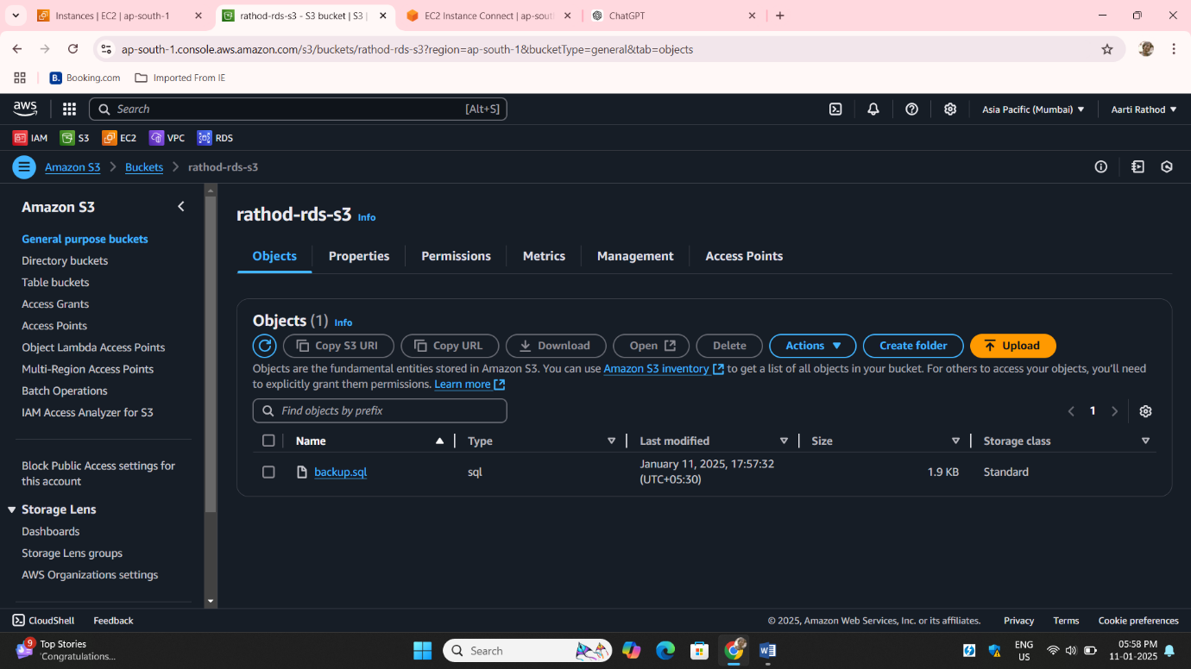**Step25**: Here your backup.sql file store in s3 we have successfully take backup of local ec2 instace create database backup to S3 with helping role: